**Recover accidentally deleted /etc/passwd or /etc/shadow files in Red-Hat**

If /etc/passwd file is missing, we may see following errors while booting the server and we cannot login to the server with any of the OS users.

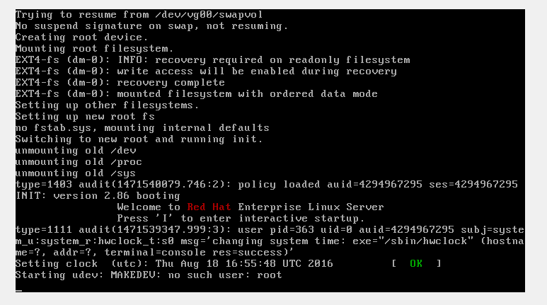

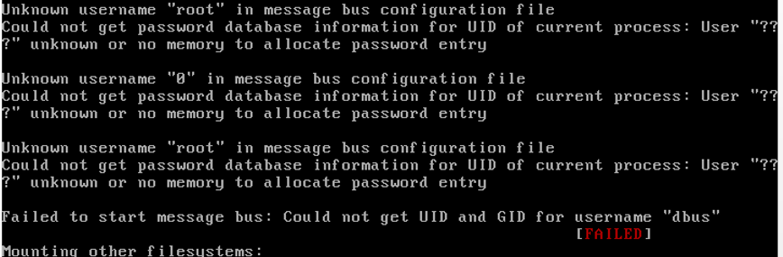

**Follow below steps to recover the deleted /etc/passwd or /etc/shadow files**.

Reboot the server and in grub phase, press “e” to boot the server in to failsafe/single user mode.

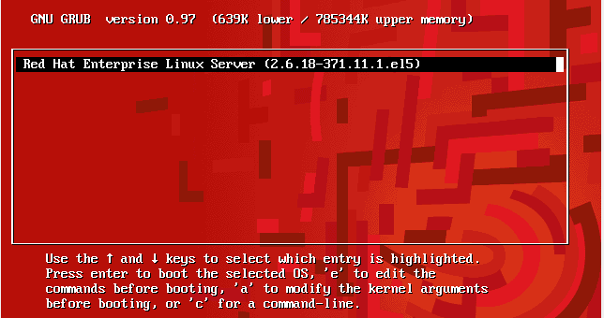

Then press “e” and select ketnel /vmlinuz-xxxxxxxxxxxxxxxxxxxxxxxxxxxxxx.

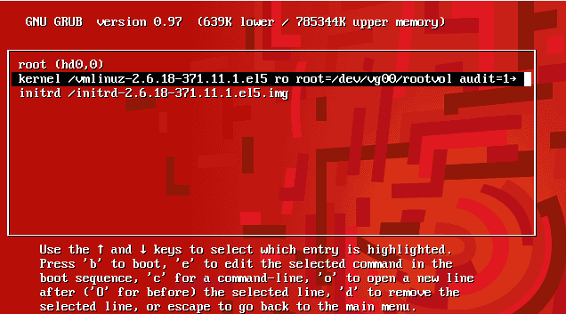

Then enter init=/bin/bash

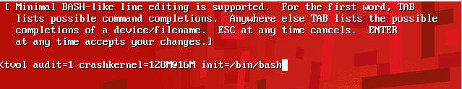

Once you enter into single user mode #, remount the / file system.

# mount -rw -o remount /

# ls –l /etc/passwd* =🡺 to check the backup files.

# cp –p /etc/passwd- /etc/passwd

# pwconv

# passwd root

Give desired passwd

#reboot –f

Once you logged backin to the server, run below commands,

#pwconv

#sync

Then validate the users, if still any users are missing, restore it from backup.

**IN SIMPLE WORDS:**

===========================================================

1. Rebooted

2. Edit Recovery Mode : with init=/bin/bash

3. mount -rw -o remount /

4. Edited /etc/passwd file(Surprisingly nano editor was working but vi dint)

5. Moved passwd- to passwd and moved shadow- to shadow.

6. Forcibly rebooted.

===========================================================

Also refer:

http://www.cyberciti.biz/tips/recovering-deleted-etcshadow-password-file.html

https://www.youtube.com/watch?v=jlI4HiRk5-M